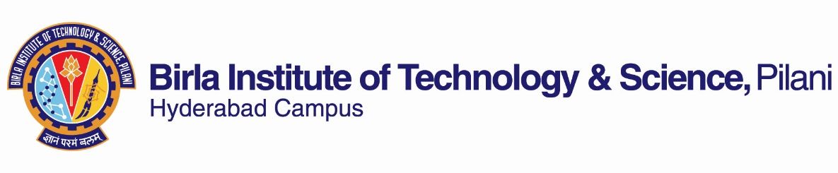
FIRST SEMESTER 2022-23
Course Handout (PART II)
29/08/2022
In addition to part I (General Handout for all courses appended to the time table) this portion gives further specific details regarding the course.
Course No. : CHEMF214
Course Title : Inorganic Chemistry I
Instructor-in-charge : Prof. N. Rajesh
Instructor-(Lec and Tut): Prof. N. Rajesh

- Course Description: This course primarily is intended to give a basic foundation to the various aspects of inorganic chemistry such as periodicity,
bonding, structures of simple compounds and chemistry of some main group elements.

- Broad Learning outcomes: The objective of this course is to provide a comprehensive survey in the topics detailed in the course plan
with the following broad outcomes: -

- Interpret the relevance of electronegativity and other periodic properties
- Illustrate the importance of acid base chemistry and applications of Hard-soft acid base concept
- Discuss the chemistry of halogens, noble gases and their significance
- Outline the basic aspects of Solid state chemistry with real-world applications.
- Explore the basic features of silicon and phosphorous chemistry
- Recognize the importance of intercalation compounds (graphite, clays) inorganic chains, rings, cages and cluster compounds

- Text Book: Huheey J. E., Keiter, Ellen A., Keiter, Richard L. Okhil K.Medhi, “Inorganic Chemistry”, 4th ed., Pearson Education 2006.
Reference Books: I. Inorganic Chemistry by Shriver & Atkins, (4th edition), Oxford . II. Cotton F.A., Wilkinson G., Murillo, C.A., Bochmann, M. “
Advanced Inorganic Chemistry”, 6th ed., John Wiley and Sons, New York (2003).

- Course Plan:

Lec No | Topics to be covered | Learning Outcome | Learning Objectives | Chapter in the Text Book
 | Concepts
1 | Introduction | Relevance of inorganic chemistry In real life applications | Basic course description  and discussion of handout | Lecture discussion
2-5 | Electronegativity | Applications and relevance in understanding inorganic concepts like acidity, color, spectroscopy etc.. | Definition, scales of electronegativity | Chapter 5
6-8 | Acid base chemistry | Relevance to environmental applications | Measures of acid base strength,  Systematic acid base interactions,  Hard soft acid base(HSAB) concept-  diverse metal-ligand interactions,  symbiosis and other applications | Chapter 8
9-11 | Solvents and molten salts | Relevance in metallurgy | Chemistry of aqueous and non-aqueous solvents,  molten salts (ionic liquids) | Chapter 9
12 | Electrode potentials | Application to hydrometallurgy | Latimer diagram to calculate EMF and  Frost diagram to predict the stability of oxidation states | Chapter 9
 | Halogens/ Noble gases
13-15 | Noble gas chemistry | Importance and applications | Early discovery of noble gases, isolation,  xenon compounds, bond strength in noble gases | Chapter 12
16-18 | Chemistry of halogens | Applications, synthetic aspects | Anomalous behavior of fluorine, Halogens oxides,  oxy fluorides, interhalogens, polyhalides,  oxy acids of halogens, halogen cations and pseudohalides | Chapter 12
 | Bonding in Solids
19 | VSEPR theory | Understand bonding | VSEPR rules (self study)  applications to simple compounds,  atomic inversion and pseudorotation | Chapter 6
20-22 | Structures of crystal lattices | Importance of Solids in diverse applications | Lattice energy, structures of  NaCl, CsCl, TiO₂, CaF₂, ZnS,  Radius ratio rules, Fajans rules- covalent character | Chapter 4
23-24 | Complex solids | Significance in world of materials | Layered structures, spinels and superconductors.  Basic aspects of band theory and crystal defects | Chapter 4
 | Main group elements-I
25-26 | Main group elements: Periodicity | Implications of main group element properties in varied applications | First and second row anomalies, diagonal relationships,  bonding in silicon and phosphorous compounds,  GroupIIIA, IVA anomalies, inert pair ,  relativistic effects and aurophilicity | Chapter 10
 | Main group elements-II
27-30 | Inorganic chains | Importance of chain compounds in catalysis and analytical applications | Catenation, heterocatenation, silicate minerals,  intercalation chemistry, one dimensional conductors,  isopoly and heteropolyanions | Chapter 11 and chapter 13 ( for iso and hetro polyanions)
31-34 | Inorganic rings | Diverse properties and practical applications | Borazines, phosphazenes, phosphazene polymers,  few heterocyclic and homocyclic ring systems | Chapter 11
35-37 | Inorganic cages | Relevance and utility in inorganic and organic chemistry | Boranes, carboranes, structure prediction for  heteroboranes,organometallic clusters | Chapter 11
38-40 | Inorganic clusters | Importance in interesting real world applications | Metal clusters, (di, tri and tetra and hexa nuclear clusters-  bonding in Rhenium and Molybdenum compounds,  Zintl ions, Chevrel phases and infinite metal chains | Chapter 13

5 Evaluation Scheme:

EC NO. | Evaluation Component | Duration | Weightage (%) | Date Time | Nature of Component
1 | Mid sem Test | 90 min. | 35 | . 04/11 1.30 - 3.00PM | Closed book
* 2. | Quiz I | 15 min | 10 |  | Open
 | Quiz II | 15 min | 10 |  | Open
*3 | Group Discussion (GD) | 10 min/group | 5 |  | Open
4. | Comprehensive. Exam. | 180 min | 40 | 28/12 FN | Closed book

*Quiz (written) dates will be announced prior and it would be conducted tentatively in the last week of Sept and Oct. GD (research article based)
is like an open book component since each group is permitted to refer the journal articles with them during discussion. GD would be held tentatively
10 days before the end of the semester. Students would be divided into 5-6 members per group with duration of about 5-7 min per group.
Topics and formation of group is left to the students’ choice (representative topics could be suggested by instructor).
Evaluation for each member would be done based on the level of participation, ability to moderate in the right direction
and knowledge of the particular topic assigned to each group.

- Make-up Policy: Make-up will be considered for only legitimate reasons with prior permission.
- Academic Honesty and Integrity Policy: Academic honesty and integrity are to be maintained by all the students throughout the semester and no type of academic dishonesty is acceptable.

- Chamber Consultation hours: To be announced in the class.

9. Notices: Relevant notices regarding the course will be displayed on CMS.

Instructor in charge
CHEM F214

